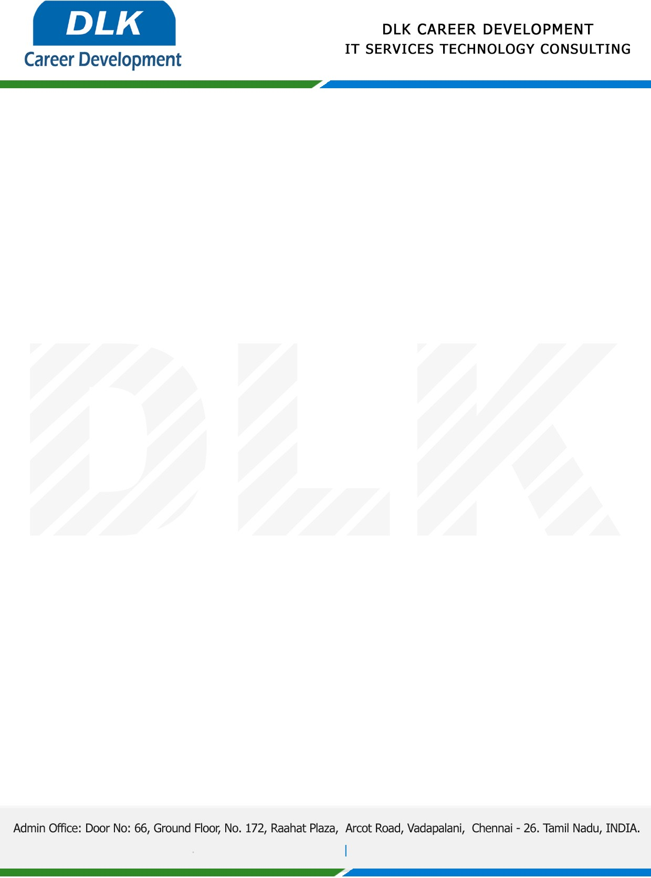

**Date: 19/January/ 2023**

**SUB: INTERNSHIP COMPLETION CERTIFICATE**

This is to certify that **MR KISHORE KUMAR S (REG NO: 113220081017) BE- Mechanical** third year student at **Velammal Engineering College, Chennai** has Successfully Completed the Internship Work under the domain of “ **Internet of Things** **”** in our organization during the Period **(26th December 2022 to 10th January 2023).**

We appreciate your interest in **DLK CAREER DEVELOPMENT**

**“Best Wishes for Your Future Endeavors “**

For **DLK CAREER DEVELOPMENT**

**HR Manager**

**VELMURUGAN J**